EF Core 8.0 Guided Hands-On Exercises
Lab 1:
Understanding ORM with a Retail Inventory System
Scenario: You’re building an inventory management system for a retail store. The store wants to track products, categories, and stock levels in a SQL Server database.
Objective: Understand what ORM is and how EF Core helps bridge the gap between C# objects and relational tables

Install EF Core Packages
Run these commands one by one.
Package 1
dotnet add package Microsoft.EntityFrameworkCore.SqlServer
Wait until it finishes.

Package 2
dotnet add package Microsoft.EntityFrameworkCore.Design
Wait until it finishes.
RetailInventory.csproj
<Project Sdk="Microsoft.NET.Sdk">

<PropertyGroup>
<OutputType>Exe</OutputType>
<TargetFramework>net8.0</TargetFramework>
<ImplicitUsings>enable</ImplicitUsings>
<Nullable>enable</Nullable>
</PropertyGroup>

<ItemGroup>
<PackageReference Include="Microsoft.EntityFrameworkCore.Design" Version="8.*" />
<PackageReference Include="Microsoft.EntityFrameworkCore.SqlServer" Version="8.*" />
</ItemGroup>

</Project>
Theory Questions
1. What is ORM?
ORM (Object Relational Mapping) is a technique that maps C# classes to database tables.
Example:
C# Class
public class Product
{
public int ProductId { get; set; }
public string ProductName { get; set; }
}
↓
SQL Table
Products

-------------------------
ProductId
ProductName
2. Benefits of ORM
- Faster development
- Less SQL code
- Easier maintenance
- Database abstraction
- Automatic CRUD operations

3. EF Core vs EF Framework
EF Core | EF Framework
Cross-platform | Windows only
Lightweight | Heavier
High performance | Moderate performance
Supports .NET 8 | Supports .NET Framework
Supports LINQ | Supports LINQ
4. EF Core 8.0 Features
- JSON Column Mapping
- Better Performance
- Compiled Models
- Improved Bulk Operations
- Interceptors
- Async Queries
- LINQ Support
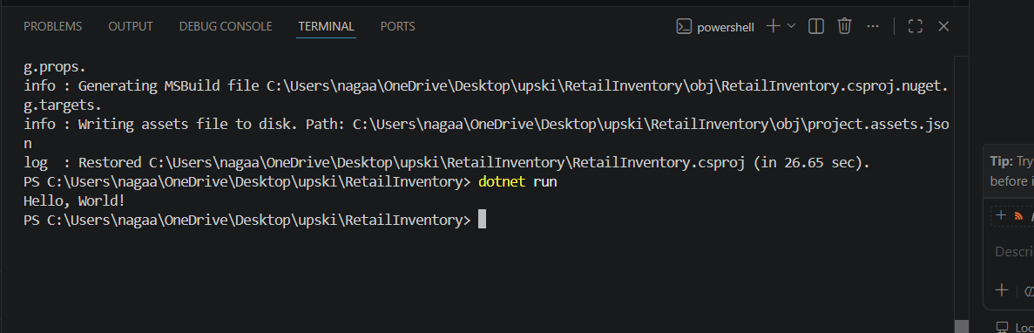

Lab 2:Setting Up the Database Context for a Retail Store
Scenario: The retail store wants to store product and category data in SQL Server. Objective: Configure DbContext and connect to SQL Server.
Code
Category.cs
using System.Collections.Generic;

public class Category
{
public int Id { get; set; }

public string Name { get; set; }

public List<Product> Products { get; set; }
}

Product.cs
public class Product
{
public int Id { get; set; }

public string Name { get; set; }

public decimal Price { get; set; }

public int CategoryId { get; set; }

public Category Category { get; set; }
}

AppDbContext.cs
using Microsoft.EntityFrameworkCore;

public class AppDbContext : DbContext
{
public DbSet<Product> Products { get; set; }

public DbSet<Category> Categories { get; set; }

protected override void OnConfiguring(DbContextOptionsBuilder optionsBuilder)
{
optionsBuilder.UseSqlServer(
"Server=HONEY\\SQLEXPRESS;Database=RetailInventoryDB;Trusted_Connection=True;TrustServerCertificate=True;"
);
}
}

Program.cs
using System;

class Program
{
static void Main(string[] args)
{
using var context = new AppDbContext();

Console.WriteLine("Database Context Configured Successfully!");
}
}

Commands Used
Install Entity Framework Core Packages
dotnet add package Microsoft.EntityFrameworkCore
dotnet add package Microsoft.EntityFrameworkCore.SqlServer
dotnet add package Microsoft.EntityFrameworkCore.Tools
Create Migration
dotnet ef migrations add InitialCreate
Update Database
dotnet ef database update

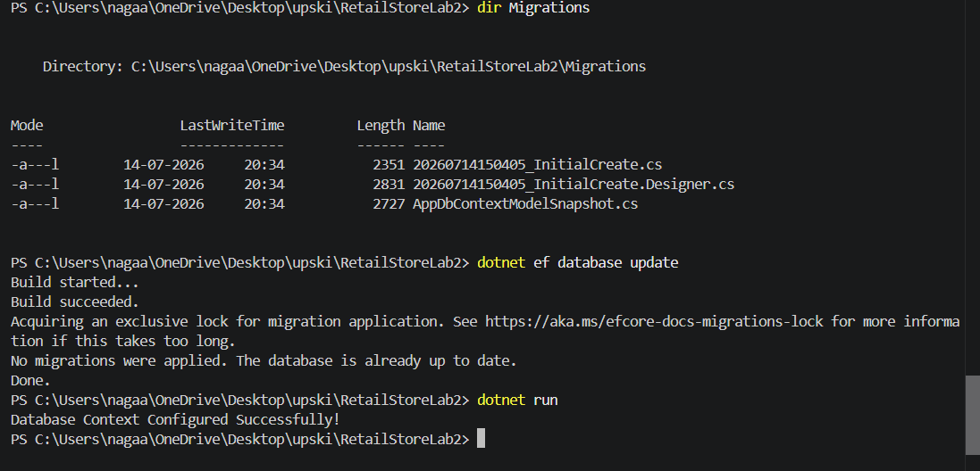
Lab 3: Using EF Core CLI to Create and Apply Migrations
Scenario: The retail store's database needs to be created based on the models you've defined. You’ll use EF Core CLI to generate and apply migrations.
Objective: Learn how to use EF Core CLI to manage database schema changes.

Category.cs
using System.Collections.Generic;

public class Category
{
public int Id { get; set; }

public string Name { get; set; }

public List<Product> Products { get; set; }
}

Product.cs
public class Product
{
public int Id { get; set; }

public string Name { get; set; }

public decimal Price { get; set; }

public int CategoryId { get; set; }

public Category Category { get; set; }
}

AppDbContext.cs
using Microsoft.EntityFrameworkCore;

public class AppDbContext : DbContext
{
public DbSet<Product> Products { get; set; }

public DbSet<Category> Categories { get; set; }

protected override void OnConfiguring(DbContextOptionsBuilder optionsBuilder)
{
optionsBuilder.UseSqlServer(
"Server=HONEY\\SQLEXPRESS;Database=RetailStoreLab3DB;Trusted_Connection=True;TrustServerCertificate=True;"
);
}
}

Program.cs
using System;

class Program
{
static void Main(string[] args)
{
using var context = new AppDbContext();

Console.WriteLine("EF Core CLI Migration Demo");
}
}

Commands Used
1. Install EF Core CLI
dotnet tool install --global dotnet-ef

2. Install EF Core Packages
dotnet add package Microsoft.EntityFrameworkCore
dotnet add package Microsoft.EntityFrameworkCore.SqlServer
dotnet add package Microsoft.EntityFrameworkCore.Tools

3. Build the Project
dotnet build

4. Create Initial Migration
dotnet ef migrations add InitialCreate

5. Apply Migration
dotnet ef database update
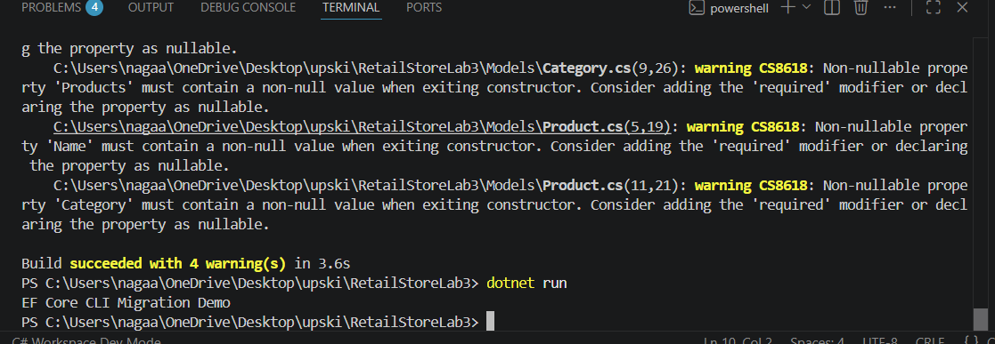
Lab 4: Inserting Initial Data into the Database
Scenario: The store manager wants to add initial product categories and products to the system.
Objective: Use EF Core to insert records using AddAsync and SaveChangesAsync.
Category.cs
using System.Collections.Generic;

public class Category
{
public int Id { get; set; }

public string Name { get; set; }

public List<Product> Products { get; set; }
}

Product.cs
public class Product
{
public int Id { get; set; }

public string Name { get; set; }

public decimal Price { get; set; }

public int CategoryId { get; set; }

public Category Category { get; set; }
}

AppDbContext.cs
using Microsoft.EntityFrameworkCore;

public class AppDbContext : DbContext
{
public DbSet<Product> Products { get; set; }

public DbSet<Category> Categories { get; set; }

protected override void OnConfiguring(DbContextOptionsBuilder optionsBuilder)
{
optionsBuilder.UseSqlServer(
"Server=HONEY\\SQLEXPRESS;Database=RetailStoreLab4DB;Trusted_Connection=True;TrustServerCertificate=True;"
);
}
}

Program.cs
using System;
using System.Threading.Tasks;

class Program
{
static async Task Main(string[] args)
{
using var context = new AppDbContext();

var electronics = new Category
{
Name = "Electronics"
};

var groceries = new Category
{
Name = "Groceries"
};

await context.Categories.AddRangeAsync(electronics, groceries);

var product1 = new Product
{
Name = "Laptop",
Price = 75000,
Category = electronics
};

var product2 = new Product
{
Name = "Rice Bag",
Price = 1200,
Category = groceries
};

await context.Products.AddRangeAsync(product1, product2);

await context.SaveChangesAsync();

Console.WriteLine("Data inserted successfully.");
}
}

Commands Used
1. Install EF Core Packages
dotnet add package Microsoft.EntityFrameworkCore
dotnet add package Microsoft.EntityFrameworkCore.SqlServer
dotnet add package Microsoft.EntityFrameworkCore.Tools
2. Build the Project
dotnet build
3. Create Migration
dotnet ef migrations add InitialCreate
4. Update Database
dotnet ef database update
5. Run the Application
dotnet run
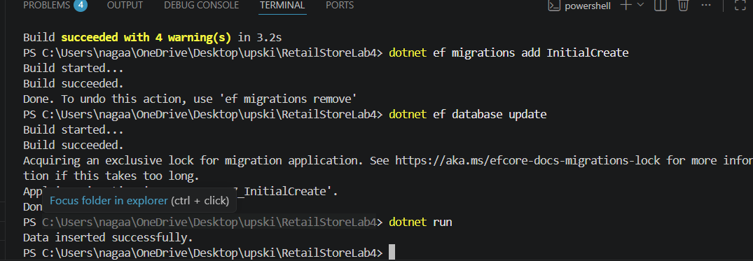
Lab 5: Retrieving Data from the Database
Scenario: The store wants to display product details on the dashboard.
Objective: Use Find, FirstOrDefault, and ToListAsync to retrieve data.
Category.cs
using System.Collections.Generic;

public class Category
{
public int Id { get; set; }

public string Name { get; set; }

public List<Product> Products { get; set; }
}

Product.cs
public class Product
{
public int Id { get; set; }

public string Name { get; set; }

public decimal Price { get; set; }

public int CategoryId { get; set; }

public Category Category { get; set; }
}

AppDbContext.cs
using Microsoft.EntityFrameworkCore;

public class AppDbContext : DbContext
{
public DbSet<Product> Products { get; set; }

public DbSet<Category> Categories { get; set; }

protected override void OnConfiguring(DbContextOptionsBuilder optionsBuilder)
{
optionsBuilder.UseSqlServer(
"Server=HONEY\\SQLEXPRESS;Database=RetailStoreLab5DB;Trusted_Connection=True;TrustServerCertificate=True;"
);
}
}

Program.cs
using System;
using System.Threading.Tasks;
using Microsoft.EntityFrameworkCore;

class Program
{
static async Task Main(string[] args)
{
using var context = new AppDbContext();

// Retrieve all products
var products = await context.Products.ToListAsync();

Console.WriteLine("Product List");

foreach (var p in products)
{
Console.WriteLine($"{p.Name} - ₹{p.Price}");
}

// Find product by Id
var product = await context.Products.FindAsync(1);

Console.WriteLine($"Found: {product?.Name}");

// Retrieve first expensive product
var expensive = await context.Products
.FirstOrDefaultAsync(p => p.Price > 50000);

Console.WriteLine($"Expensive Product: {expensive?.Name}");
}
}

Commands Used
1. Install EF Core Packages
dotnet add package Microsoft.EntityFrameworkCore
dotnet add package Microsoft.EntityFrameworkCore.SqlServer
dotnet add package Microsoft.EntityFrameworkCore.Tools
2. Build the Project
dotnet build
3. Create Migration
dotnet ef migrations add InitialCreate
4. Update Database
dotnet ef database update
5. Run the Application
dotnet run
